Is Faster Expansion of Public Expenditure Affordable?

By Mick Foster
This note presents some economic analysis of Labour expenditure proposals, as set out in the Manifesto, compared to existing Government plans, and compared to a more ambitious scenario.
Before presenting the data, it is important to acknowledge the sizeable BREXIT elephant in the room. BREXIT will devastate these forecasts if it goes ahead in a form that denies us access to the single market. Growth and revenue will be lower. Spending to achieve the same ends will be much higher as the UK devotes resources to expensively providing in one country all of the many services currently provided at EU level, including recruiting and training the necessary workforce. The strongest argument for staying in the EU or at least the single market is that the Labour manifesto will not be deliverable if we are simultaneously seeking to extricate ourselves from the EU.

Labour Spending Plans: Better than the Conservatives – but still too timid
The public expenditure proposals in the Labour manifesto represent a significant improvement on Tory plans. A £48bn increase in current expenditure by 2021-22 plus an investment fund spending £25bn per annum implies public expenditure growth of about 3% p.a. in real terms compared to 2017-18. Public expenditure in 2021-22 would be 41% of GDP, significantly higher than the 37.2% of GDP planned by the Conservatives. Public expenditure has been above 41% of GDP in 22 of the last 70 years, so the plans are not unreasonable when public infrastructure and services need to be re-built after prolonged austerity and neglect.

Source: Calculated from Office of Budget Responsibility databank, and Labour Manifesto, ‘For the Many, Not the Few.’
To examine the impact on the debt and on debt service, we need to make some assumptions about the phasing of increased spending and revenue. The most pessimistic assumption from the point of view of the impact on debt is that the expenditure increase is front-loaded, with spending increasing to 41% of GDP in 2018-19 to deal with immediate problems, and then maintained at that level. On the revenue side, I assume that receipts cover current expenditure plus depreciation, with investment financed in each year by net borrowing. Investment spending is assumed to be £25bn higher than Conservative plans in each financial year (equivalent to the Labour £250bn investment fund spending at an even rate over the proposed ten year period). On these assumptions, revenue as a share of GDP peaks at 38% in 2019-20 and then starts to fall.

Figure 2:Labour Manifesto Plans and Financing

Source: Calculated from Labour Manifesto, 2017, and from OBR GDP growth forecasts. See text for assumptions. Data are for financial years ending in the specified year
The Government likes to imply that reducing the debt burden requires Government to run a budget surplus. This is not true. If Government has to borrow 3% of GDP to cover a budget deficit, the size of the debt still falls as a percentage of GDP if GDP grows by more than 3%. The increased level of net borrowing under labour plans would require net borrowing of about 3.2% per year, about the same as the projected rate of increase in GDP as a result of inflation plus economic growth.
Under Labour plans, assuming unchanged OBR forecasts of GDP growth, the net public debt would remain at about 90% of GDP throughout the five year period. In practice, higher public spending should result in higher economic growth, so this is a highly pessimistic assumption. However, even if the level of debt as a share of GDP remains unchanged, there is no particular cause for alarm at this level of indebtedness. International comparisons suggest that Government debt in the UK is not uniquely high by international standards (Figure 3). It is below the United States, France and Canada.

Figure 3 General government debt Total, % of GDP, 2015
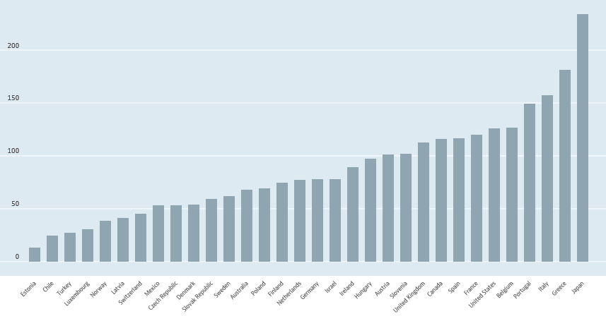
UK
Source: OECD, https://data.oecd.org/gga/general-government-debt.htmThe numbers differ from the UK specific analysis because they are based on general Government debt rather than net debt.
Even more important than the size of the debt is the fact that servicing the debt will not be a problem. On OBR assumptions about future interest rates, the cost of interest payments will remain at about 2% of GDP throughout the period (Figure 4). The interest savings from all of the painful Tory austerity in prospect are negligible:- Labour in 2021-22 will be paying 2.1% of GDP as interest, compared to 1.9% under Tory plans. If we make the not unreasonable assumption that higher Government spending boosts economic growth, the increase will be even less. Higher interest rates are a potential risk, but would still be easily financed. The level of interest payments will be significantly lower as a share of GDP than for most of the post war period, making nonsense of the claim that the debt is the most important problem facing the country. A far bigger threat to the future growth and stability of the economy is the build-up of private debt – much of it the result of the pressure that austerity policies have imposed on households.

Source: OBR database

Is the Labour Manifesto too cautious?
Although the continuation of public debt at about 90% of GDP for the next few years should be easily manageable, a cautious Government might reasonably wish to avoid seeing it increase much further, especially given the uncertainties surrounding our future relationship with the EU. Higher expenditure would therefore need to be financed by raising more revenue.

Figure 5 General government spending, % of GDP, 2015
Source, OECD, https://data.oecd.org/gga/general-government-spending.htm
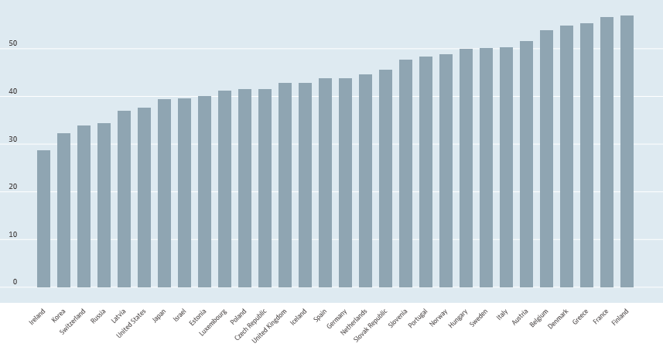
UK
Increased taxation to fund better public services needs to be put firmly back on the agenda, and put to the electorate in a future general election. Median Government spending among high income countries is significantly higher than in the UK. It is above 40% of GDP according to OECD data (Figure 5). The further cuts since 2015 have seen us drift further down towards the low-tax, low-spend end of the table, where states are unable to finance reasonable services and social safety nets for their people. If we aspire to a form of social democracy closer to the Scandinavian model, we probably need to spend at levels closer to theirs.
This does require higher taxation. Denmark, Sweden, France, Austria, Finland all have tax:GDP ratios above 50% (Figure 6). We may not want or need to go that far, but a credible case can be made that somewhat higher taxation, levied equitably, is a price worth paying for a society that cares for the many not the few, and that provides a high standard of public services and economic infrastructure. It is no accident that Scandinavian countries who spend a significantly higher share of GDP through Government also achieve high scores on indices of happiness.

Figure 6 General government revenue Total, % of GDP, 2015
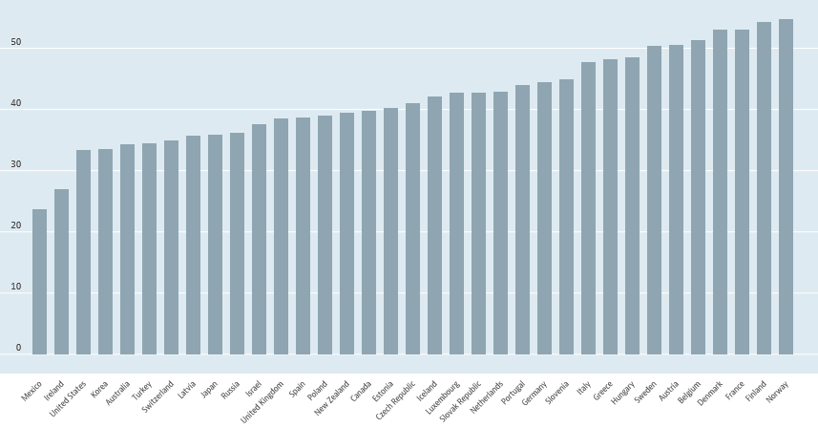
UK
Source: OECD https://data.oecd.org/gga/general-government-revenue.htm
To illustrate what might be feasible, I have calculated the impact of raising public expenditure to 44% of GDP. Assuming net borrowing of 3% of GDP, this could be financed by increasing the tax take to 41% of GDP.
With unchanged debt levels, the higher taxation would allow expenditure growth of 4.8% per annum, and would mean that Labour would have £70bn more to spend in 2021-22 than under the plans set out in the manifesto, equivalent to a 7% increase in total public expenditure. To give some idea of the significance of this increase, it is equivalent to the cost of raising NHS spending from the current level of about 7% of GDP to the 10% of GDP spent by France and Germany on their publicly funded health systems.
These numbers are purely illustrative, intended to start a debate on the future country we wish to see. We have allowed ‘high tax and spend’ to become terms of abuse that prevent serious discussion of the very real alternatives that we face. It is long past the time when we should move the debate on to give people a real choice as to the public services they want and are prepared to pay for through taxation.

Mick Foster is a Senior Research Associate of the Overseas Development Institute, and a former Senior Economic Adviser in the Government Economic Service

